- Employee Engagement –
- Highly Engaged
- Moderately Engaged
- Moderately Disengaged
- Highly Disengaged
Remarks: To create 4 such liquid fill gauges each representing the above 4 criteria in an animated format
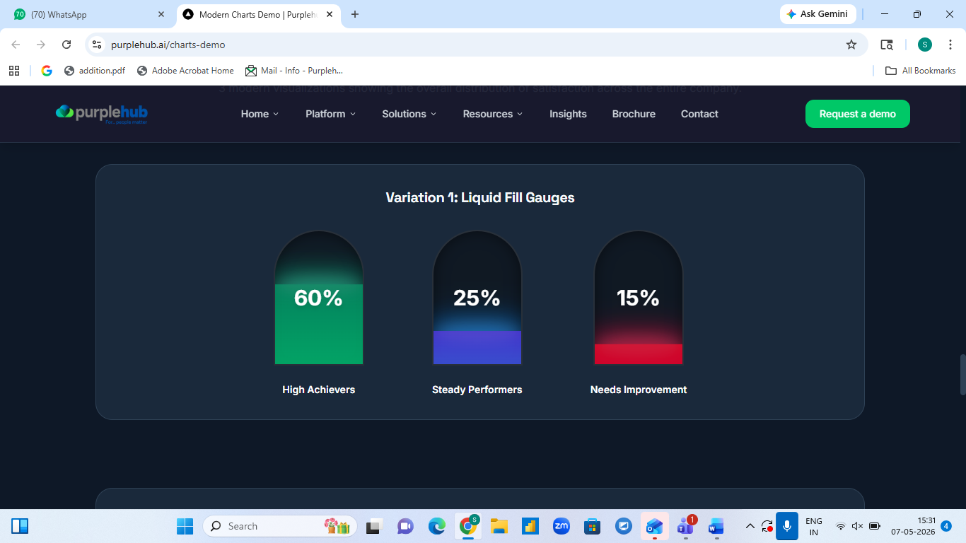

- For high achievers, steady performers, needs improvement
Remarks : To retain as is
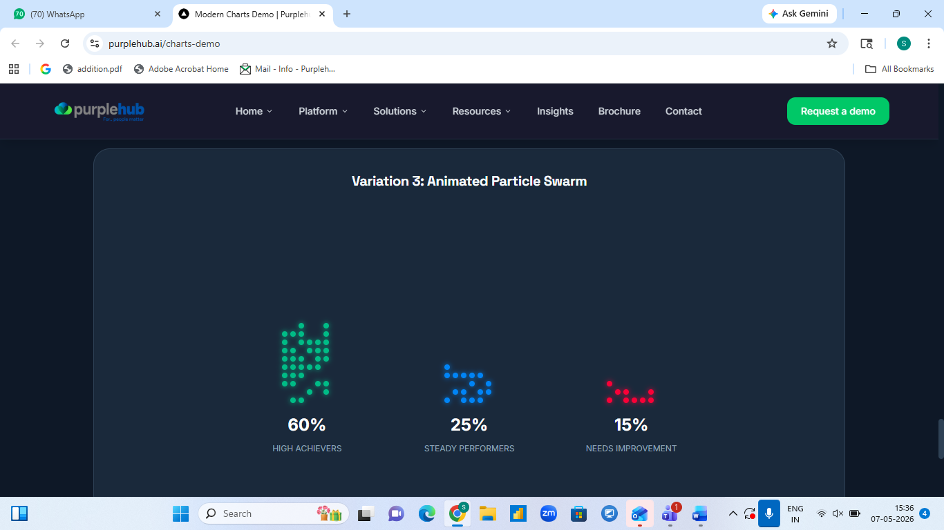

- Live Speedometers
Remarks : To retain as is
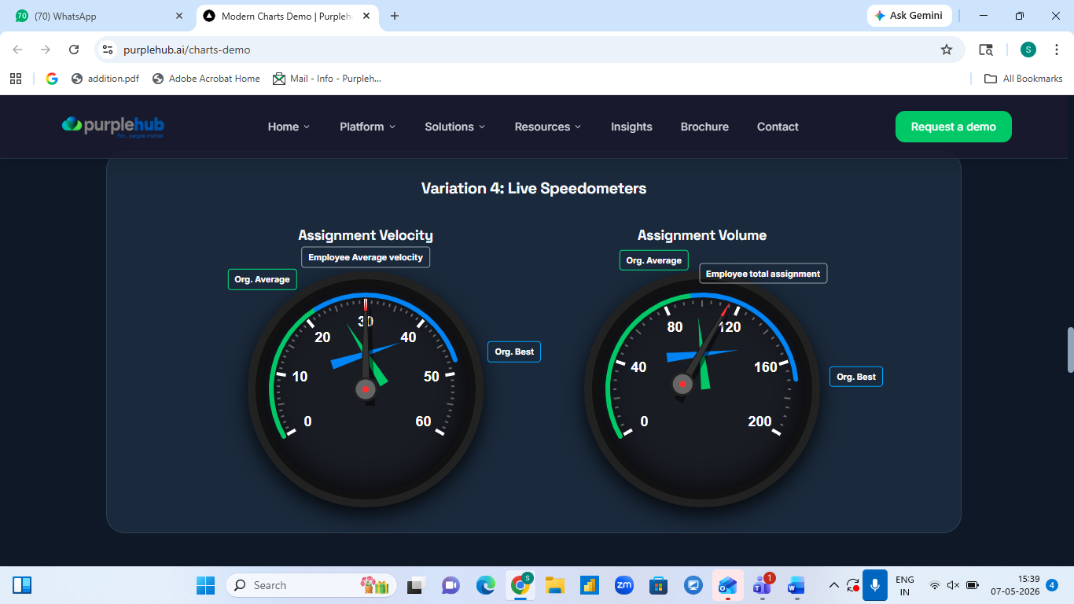

- Futuristic radar web
Competency List -
- Business Acumen
- Collaboration
- Communication
- Technology
- Execution
Remarks : To create a radar chart , giving a comparison between the ideal requirements for the role (the outer layer) and the employee's current actual scores (the inner layer) on the above listed competencies -
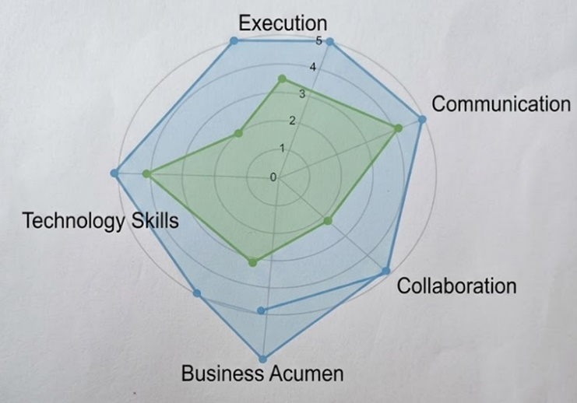
- Value Chart
Remarks : to retain as is
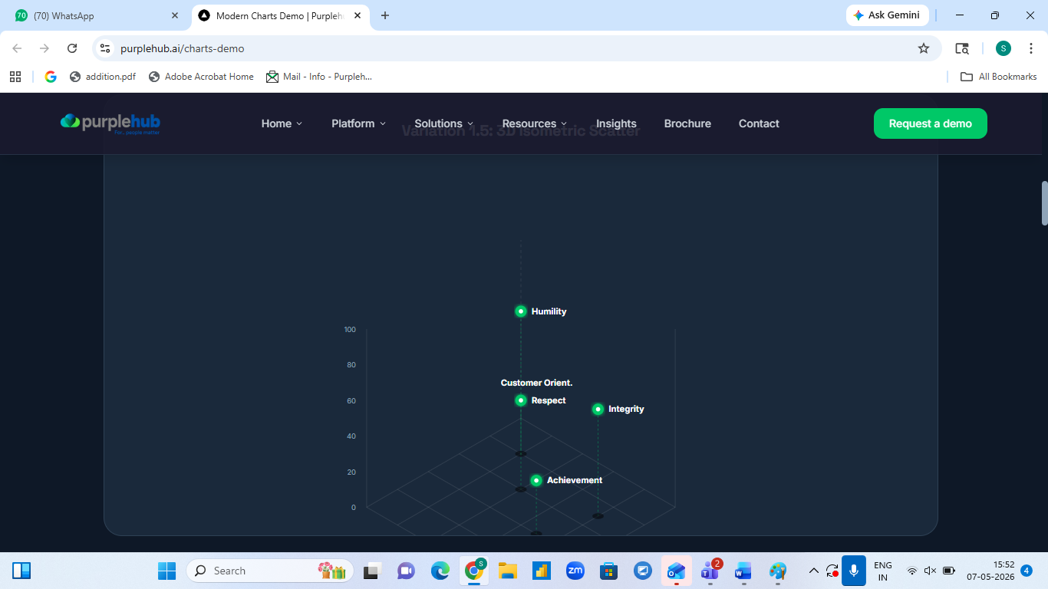

- High performing teams and their leaders
Remarks: please give us a better version for the below chart. The below chart is highlighting top-performing teams with the corresponding managers who have been the pillars is guiding, providing clarity, support system, coaching and guiding the team to raise up to higher level.Each manager with a specific numerical metric represents the overall team performance scores.
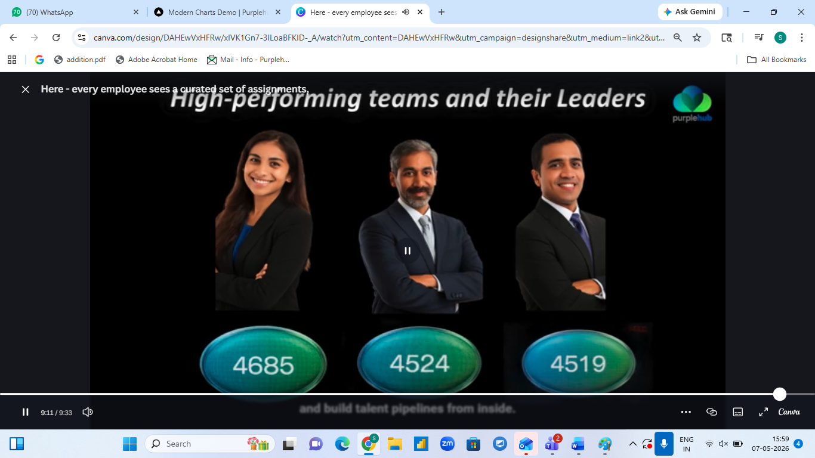
- Feedback personas –
Remarks : The image illustrates "Feedback Personas," wherein a lenient "Liberal manager" Vs a data-driven "Caring Critic manager." Most of the individual while giving feedback lean toward giving pleasing scores to maintain a positive image. But the true essence of feedback iss to move towards a more judicious, objective approach that uses data, facts based feedback to enhance ones growth.
You may want to provide a better chart version here.

